Northwest
Parent Handbook
_____________________

Welcome Letter

Welcome Parents and Students!
Thank you for choosing Salt Lake City School District, (SLCSD) Northwest Community Education Summer school for your student’s summer learning experience! We know you have a lot of choices, and we are glad that you chose SLCSD. We are looking forwards to a safe and fun summer. We are dedicated to helping your student have the best summer that they can. Below you will be able to read about our mission, vision, core values, and goals.

Mission:
Community Education provides a range of enrichment experiences that ensure every student is Ready for Tomorrow.

Vision:
Every student in SLCSD will have life-long learning access to high-quality programs through the Community Education Department.

Core Values:
- We believe learning is a life-long process.
- We believe everything is possible if we have the best interest of students in mind.
- We believe that our programs provide a broad range of learning possibilities that reflect the needs and interests of the SLCSD community.
- We believe that our department supports, supplements, and complements SLCSD programs while providing enrichment options to our community at-large.

Goals:
- Our goal is to provide a safe, nurturing, environment for students to experience indoor and outdoor adventures and to grow socially, emotionally, and physically so that they may reach their greatest potential.

The Parent Handbook is a resource for policies and procedures for the Summer School Program. We encourage you to take the time to read through this with your student. If you have any questions or concerns, please do not hesitate to contact us!

Sincerely,

Summer School Program,
The Community Education Department

The Northwest Team
Mo Mulitalo  Northwest  (801) 578-8547 | Sulieti Taumoepeau  Community Education After-School Coordinator  801-578-8547
Liz Gonzalez  Supervisor, Community Education  (801) 578-8485 | Maxine Gilmore  Title 1 – Administrative Assistant  (801) 578-8275
Tim Perkins
Program Specialist
(801) 578-8399

About Our Summer Program

What to expect at the Summer School:
This summer we are excited to partner with the Teaching and Learning department to support students' summer success in the areas of Science, Mathematics, Fine Arts, Language Arts, Social and Emotional learning. Students will have the opportunity to engage in educational hands-on learning STEAM (science, technology, engineering, art, and math) activities on and off campus, to makes gains in core curriculum, learn new skills, and enjoy making new friends!
Summer focus: We strive to create an outstanding experience for your student each day with highly qualified certified teachers, paraprofessionals, and Community Education professionals. Students will gain experience collaborative learning groups that support student engagement core curriculum, social and emotional lessons, that support student summer success. Students will also have an opportunity to participate in a National Summer Learning week showcasing student art and STEAM creations. The summer Northwest Program is designed to capture the attention and interest of your child.
The Summer Program offers academic morning classes and STEAM enrichment morning and afternoon activities. Our students will explore, discover, and learn weekly through fun, hands-on interactive STEAM enrichment activities.

Days – Times:
  - Monday – Thursday
  - 8:00 AM – 3:00 PM

Grades:
- ONLY available to incoming 7th – 8th grade students who attended a Salt Lake City School District school for the 2020-21 school year.

Parent Responsibilities:
- Parents/Guardians must follow all established policies and procedures outlined in the Summer School Program Parent Handbook including the payment policy, the refund policy, the late pick-up policy, etc.
- Parents/Guardians are responsible for reading all emails, handouts, flyers, etc. sent home regarding the Summer School Program as well as regularly reviewing the Northwest and Community Education website and materials available to keep well informed about the program.
- Parents/Guardians have a right to have any and all of their questions answered, and their concerns addressed. If a parent/guardian have any questions or concerns. The Site Coordinator of their home school will be available to support the parents' concerns and student needs.
- We aim to provide a fulfilling and meaningful experience for all of our students. When you send your child to the Summer Program, you entrust us with their care. We take this responsibility seriously, but we are only as good as the information that we are given. Therefore, we ask that you work with us to provide detailed and accurate information so we can better prepare our team to create a positive and rewarding experience for your child. The better prepared we are before program, the better we can help your child be successful once they are here. If your student requires special accommodations, please let us know during the registration and check-out process.

Program Overview

Weekly Schedule (Sample):

Summer School 2021
5 weeks
June 14 - July 15
8:00 AM | Breakfast at the home school
8:30 AM | Prime Time Rotations
11:30AM | 30-minute Lunch
12:00 PM | Afternoon Enrichment Rotations
3:00 PM | End of program

Behavior Expectations

Student Code of Conduct:
- All students and staff have a right to learn and teach in a safe, caring and respectful environment in order to achieve their maximum potential academically, socially, emotionally, and ethically.
- Any behavior that is demeaning, lessens self-respect and esteem, or limits a student’s ability to learn or a teacher’s ability to teach will be considered a violation of personal rights.
- Students are expected to abide by these four (4) behavior expectations:
- Be Safe  - Keep hands, feet, mouth, and objects to yourself  - Walk in the building | - Be Responsible  - Use materials and equipment properly  - Be in the proper place at the proper time
- Be Caring  - Kind words and actions | - Be Respectful  - Follow directions the first time given  - Quiet voices in the building and/or the bus
- Our policy in handling disruptive children is as follows:
- First occurrence, the instructor will discuss the situation with the student. Participant will be issued a warning and parent will be notified.
- Second occurrence, the instructor will have the student sit out for some time to cool off and fill-out a Think Sheet. Parent will be notified. Think Sheet will be sent home.
- Third occurrence, the Program Specialist will schedule a parent conference when the child exhibits a pattern of disruptive behavior that interferes with the quality of the program or management of other students.
- If the behavior of the child persists, the parents/legal guardians will be notified of dismissal from the program. No refunds will be authorized in the event of a dismissal.
- The Community Education department, SLSD, has a zero-tolerance policy. Any student who is threatening the safety of themselves, other students, or the instructors will be immediately removed, and no refund will be issued.
- At the staff's discretion, any consequence may be bypassed due to the severity and nature of a student behavior.

Bus Expectations:
- Most field trips are not within walking distance of the Program and will require transportation via a bus.
- The Student Code of Conduct applies while riding on the bus.
- Students who are transported for field trips are expected to behave in a courteous and respectful manner while waiting to board the bus.
- Students are expected to conduct themselves in a courteous and cooperative manner on the bus at all times.
- The bus driver is in charge of the bus and has the right to administer disciplinary actions including assigned seats to maintain order and promote safety.
- Riders may not shout or display any behavior such as loud and boisterous talking or laughing that may distract the driver and compromise the safety of those on the bus.
- Students are to be properly seated while the bus is in motion and are prohibited from putting objects and/or body parts out the windows of the bus at any time.
- Riders must not tamper with the bus emergency door.
Program Items
Backpack Items:
Below is a checklist of recommendations for your students’ summer success. We might be traveling on field trips and students will be engaged in active hands-on learning, so it is important to be prepared for the average Student’s day of fun!
- Hat
- Sunglasses
- Snacks
- Closed toe shoes
- Light jacket
- Refillable Water Bottle
- Sunscreen/Insect Repellent

Dress Code:
- Send your child to program in comfortable shorts, t-shirts and sneakers appropriate for the weather. We get very dirty in some of our activities; older clothes/shoes are recommended.
- Sneakers/tennis shoes are required for safe participation in active play. No sandals, open-toed shoes are permitted; Crocs and “wheelie” shoes are also not permitted.
- Clothing that does not cover undergarments and/or featuring inappropriate graphics such as profane language/messages, drugs/alcohol or violence is not permitted to be worn during program.
- Hats and sunglasses are worn outside not in the building.
- Do not send your child to program with unsafe apparel such as jewelry or accessories with chains, cleats, spikes, or studs.
- Please send swimsuits, towels, and sunscreen on swim days.

Sunscreen/Insect Repellent:
- The Summer Program does not provide sunscreen or insect repellent. Each student should be sent to program with his or her own bottle of sunscreen and bug repellent. Please label these bottles with your students full name. It is strongly recommended that parents apply sunscreen to their child each morning.
- For ease of application as well as privacy concerns, we recommend sending your student with a spray/no-rub sunscreen and/or insect repellent.

Do Not Bring to Program
- Parents will be notified in advance if students are allowed to bring items on this list for a specific, pre-approved activity, and how the items are to be removed from school property after the conclusion of the activity. The following items are prohibited, and if brought to school by students, may be confiscated:
  - Sports equipment such as hard balls or bats, basketballs, footballs
  - Musical equipment such as radios, recorders, cassette players, tapes, CDs, CD players, iPods and other mp3 players
  - Electronics such as radios, recorders, iPods, etc.
  - Toys such as trading cards, any board game, card game, or “toy” weapons
  - Animals (no animal will be permitted in the building, classroom, or at a school function):
    - The provision of emotional support, well-being, comfort, or companionship do not constitute work or tasks for the purposes of this definition. The service animal must be:
      - required because the individual has a disability; and
      - individually trained to do work or perform tasks for the benefit of the individual with a disability.
    - An emotional support, therapy, and/or comfort animal is not considered a service animal. Service-animals-in training are not considered service animals under the ADA; under the ADA, the dog must already be trained before it can be taken into public places.
  - Grooming aids such as makeup, perfume, nail polish, hair spray
  - Wheels - non-motorized transportation to program is encouraged. However, students are prohibited from riding all wheeled equipment (bikes, scooters, skateboards, “Heelys”, roller blades, etc.) on school grounds.
  - Weapons such as knives, firearms, matches, guns, darts, bullets, arrows, caps, firecrackers, stars.
  - Food such as gum, candy, bottled soda/pop
  - Money
  - Inappropriate reading material
  - Drugs/Alcohol/Tobacco products, the Summer Program is a substance free for all participants and staff. The use, possession, or suspicion of possession or impairment of any illicit substance or alcohol can result in dismissal from the Summer Program and referral to the appropriate authorities. All drugs, alcohol, and tobacco products (including e-cigarettes or vapes) are prohibited from the Summer Program.
  - Zero Tolerance: If a student is caught with any weapons, drugs, alcohol, or tobacco products, they will be removed from the program and no refund will be issued.
  - Absolutely nothing will be allowed at school that is intended, recognized, or acknowledged by the Metro Gang Task Force, to signify affiliation with, participation in, or approval of a gang.

Electronic Devices:
- Students bring personal electronic devices on school property or to school activities at their own risk. SLCSD is not responsible for borrowed, misused, lost, stolen, or damaged personal electronic devices.
- Students may have electronic devices in their possession during the regular program hours. Personal electronic devices must remain out of sight during program instructional time AND be turned off OR on a silent mode.
- Picture taking or recording by students is strictly forbidden in school or school activity private areas, such as locker rooms, counseling sessions, restrooms, and dressing areas.
- Students may use electronic devices in situations that threaten the health, safety, or well–being of students (including themselves), school employees, or others.
- Personal electronic devices may not be used during program or program field trips.
Health Policy

Bee Sting Allergies:
- Parents of children with known bee sting allergies must complete a Food Allergy & Anaphylaxis Emergency Care Plan and submit it with their enrollment paperwork. If a child with an allergy is stung, we will implement the Food Allergy & Anaphylaxis Emergency Care Plan and parents will be notified. Any time an EpiPen is administered, is to call to 911 and then notify parents.

Concussion or Traumatic Head/Brain Injury (TBI):
- The most common type of TBI is a concussion. A concussion can occur even if a student does not lose consciousness. If a student is suspected of sustaining a concussion or TBI, then parents will be notified of the injury and the need for a proper medical evaluation before the student can come back to program. The Summer Program will ensure that documentation of a completed proper medical evaluation is obtained prior to the student being allowed to return to play.

Food Allergies:
- Many students have food allergies. If your child has a food allergy, please let us know and complete a Food Allergy & Anaphylaxis Emergency Care Plan and submit it with their enrollment paperwork. Any time an EpiPen is administered, our protocol is to call to 911 and then notify parents.

Illnesses:
- Students are encouraged to participate when present, unless sick or injured, in which case parents will be notified and student will be sent home. Students too ill to participate in program activities will remain in the program office until a parent can pick them up from program.
- If you suspect your child has any of the symptoms listed below, please do NOT send him/her to school. We urge you to seek medical attention for diagnosis and treatment as needed. Please follow the Guidelines for Illness for specific criteria.
- Students who have been diagnosed with a contagious disease may not return to program without a doctor’s written permission. Please contact the Northwest Summer Program site coordinator and keep your student at home as directed by the physician.
- All incidents requiring first aid (wash cut with water and apply a bandage) will be recorded and then verbally reported to parent at pick-up.

Medication:
- Program staff do not diagnose injuries or illnesses and may not administer any medications in connection with an accident. All incidents requiring first aid (wash cut with water and apply a bandage) will be recorded and then verbally reported to parent at pick-up.
- A student may carry and self-administer the recommended dosage of a necessary over the counter medication. Parents of students self-administering over the counter medication should inform school personnel that the student has the medication in their possession and has their permission to self-administer it.
- A student may carry and self-administer the prescribed dosage of a necessary prescription medication for medical treatment of illnesses, injuries, diseases such as asthma, diabetes, or extreme allergic reaction, if the parent and healthcare provider have completed and submitted a student medication form to the program (S-9: Student Medication Form).

Important Information

Absences:
- If your Student is going to be absent from program, please contact the Summer Program coordinator to report the absence. If a student misses a day, they are encouraged to come all other days.

Changes to the Check-out List:
- To authorize self-check-out or to add people to your pick-up list, please come into the Summer Program office and speak to our Summer Program Specialist.

Check-in/Check-out Procedures:
- You will need to be prompt in dropping off and picking up your child. We do not have the staff to accommodate early arrivals or late pick-ups.

Check-in:
- Program Leadership staff will be available from 8:00 AM – 8:30 AM with rosters to check-in your student.

Check-out:
- Community Education requires that those picking up students at the Summer Program are listed as approved to do so (including parents) on the Check-out list.
- Student may walk home with parents’ permission.
- Transpiration is available with parents’ permission, with in the Northwest boundaries.

Closed Campus Program:
- We operate a closed program campus which means that all students are to remain at program during the day. Students are required to stay on the school grounds during program hours. They are not to go to the store or a friend’s home during the time they are in program including recess and lunch periods.

Concerns:
- The majority of problems arising in a program can be solved through consultation between the student, parent, and program employees.
- Concerns should be brought to the attention of program employees starting at the lowest level. Any concerns that you have with the Summer Program please follow the process described below:
- Parent contacts the Group Leader by speaking to the Group Leader about the concern with the student.
- After speaking with the Group Leader and student directly, if a resolution was not reached, the parent meets with the Site Coordinator, Group Leader, and student.
- After meeting with the Site Coordinator, Group Leader, and student, if a resolution was not reached, the parent then meets with the Site Coordinator, Group Leader, Program Specialist, and student.
- The final recourse in this process is to meet with the School Administrator.

Early Arrivals:
- Please do not drop off your child more than ten minutes before the program begins. The Summer Program Staff does not assume responsibility for any child dropped off unattended. Supervision begins at 8:30 AM when program begins. Transportation is provided for students who live in the Northwest boundaries.

Early Pick-Up or Late Arrivals:
- In cases when you may be picking up your child early, please let the Leader know ahead of time, as the groups do go off-site for outings. Please make sure that you personally tell your child’s leader that you are taking the child and follow the sign-out procedure.
- Students start afternoon rotations, specials, and contract services after lunch. This is a good transition time for students who need to be picked up early or arrive late.

Late Pick-Up:
- Supervision ends when program is complete for the day at 3:00 PM. If a child is not picked up promptly after program, you will be charged a late fee of $5.00 for each 10 minutes the child is left after program ends.
- This does not apply if you are delayed due to an emergency. Please contact the Northwest Summer Program staff at (801) 578-8547 to alert us to any emergency situation, e.g. car trouble, etc.

Personal Property Policy
- Each summer many items of clothing are left at program and cannot be returned because there are no owners’ names on the items. We highly recommend that all personal property items are clearly labeled with name and contact information. The Summer Program assumes no responsibility for lost, stolen, or damaged personal property items.

Payment Policy

Payment Methods:

The cost of the Northwest summer program is Free.

Cancellation Policy

Cancellation of a Weeklong Program:
- If fewer than the minimum number enroll, the weeklong program will be cancelled. Parents will be notified in advance. The Northwest Program reserves the right to cancel any program due to low enrollment. Programs cancelled by the Northwest Program will automatically be 100% refunded.

Waiver and Release Policy

Consent to Participate, Treat, and Release Agreement:
- This Agreement must be acknowledged and certified by Parent(s), Legal Guardian(s) during time of check-out in order to participate in the activities associated with the Northwest Summer Program.
  - I state my child is free from any known heart, respiratory or other health problems that could prevent my student from safely participating to illness, injury, or death.
  - I have received, understand, and will abide by the Salt Lake City School Districts Administrative Procedures for Board Policy S-6: Concussions and Traumatic Head Injuries. (Download a copy at https://www.slcschools.org/board-of-education/policies/s-6/s-6-policy/english/, or if you would like a paper copy contact the Community Education central office at 801-578-8275).
  - I give consent for my student to participate in the Northwest Summer Program. I understand that participation in the Summer Program can include foreseeable and unforeseeable risks and other hazardous activities inherent in the program, which may expose my student to illness, injury, or death. I have explained the activities of the Summer Program to my minor child and have discussed with him/her the potential risks of participation.
  - I give consent to take my child to public indoor/outdoor swimming pools during designated “open swim” periods. There will be on duty lifeguards as well as SLCSD Summer Program staff in and outside the water to supervise students. We take safety seriously and the expectation is that students are to follow the pool rules. If you object to this consent, then you have to let the Summer Program staff know immediately. We will make accommodations for your child at the pool area.
  - I hereby give my express consent in the event of injury for the Salt Lake City School District to obtain for my child any necessary emergency aid, anesthesia, and/or operation, if in the opinion of the attending physician, such a treatment is necessary.
  - I further agree to release Salt Lake City School District (SLCSD) employees from any and all liability, claims, demands, actions and causes of action whatsoever arising out of or related to any loss, damage, injury, illness, attorney's fees or harm of any kind or nature to me arising out of my student's participation in the Summer Program and excepting only such loss, damage or injury as may be caused by the sole negligence of any releasee. This release extends to any claim made by parents or guardians or their assigns arising from or in any way connected with the aforementioned activities.
  - I give consent for my child to participate in the Northwest Summer Program, and I execute the above liability release on their behalf.
  - SLCSD requires all students to use the district’s network resources in a responsible, ethical, polite, efficient, and legal manner. I have reviewed with my child Salt Lake City School Districts Board Policy I-18: Acceptable Student Use of Internet, Computers, and Network Resources. Use of the district’s network resources is a privilege and may be revoked at any time for failure to comply with this policy.
  - Parents or eligible students should complete and submit the district’s S-2: Media Release Form to the Community Education Department if they wish to opt out of giving media consent.

Wait List Policy

First Come First Serve:
- Our waitlist policy will be on a first come first serve basis.
- Ten (10) days prior to each program, parents/guardians will be contacted via email notifying them of openings in the program.
- To claim a spot, you must you call Community Education at 801-578-8275 to register.
- Note: you will not be removed from the wait list unless you request it. You will remain on the list in case another spot opens.

Forms

Food Allergy & Anaphylaxis Emergency Plan
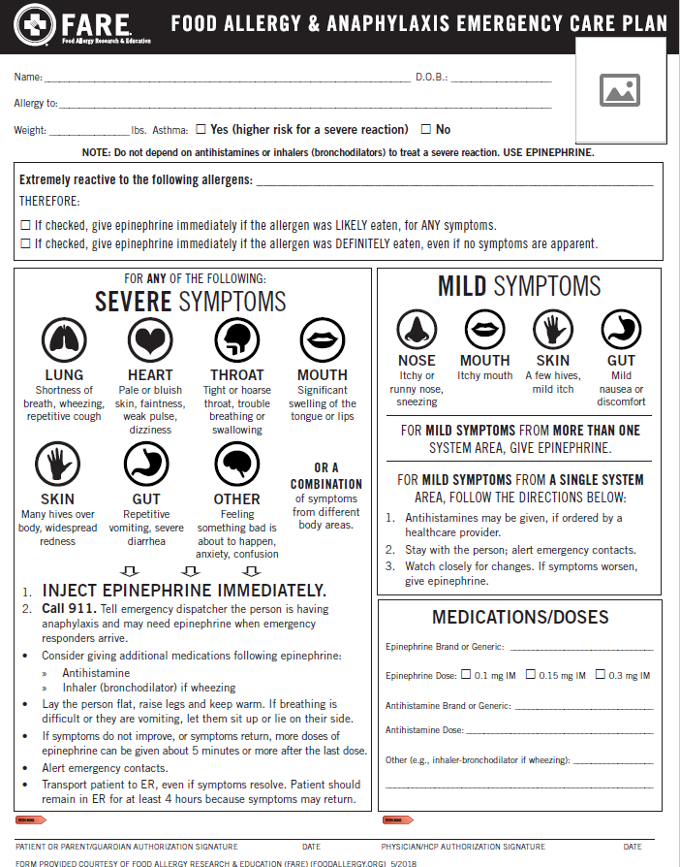
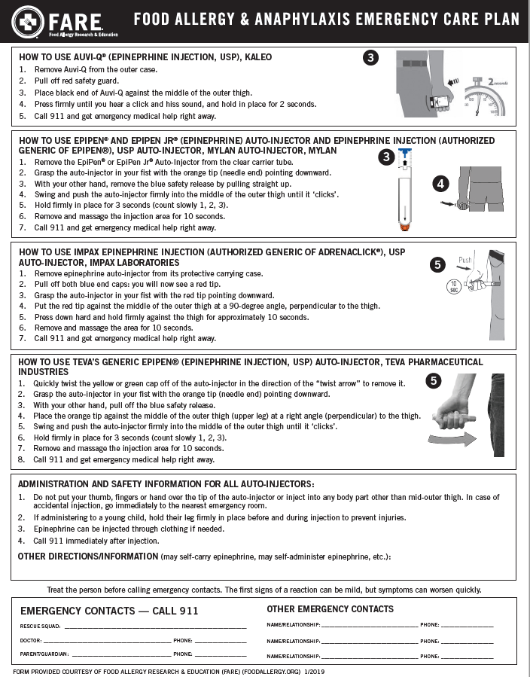
Food Allergy & Anaphylaxis Emergency Plan SPANISH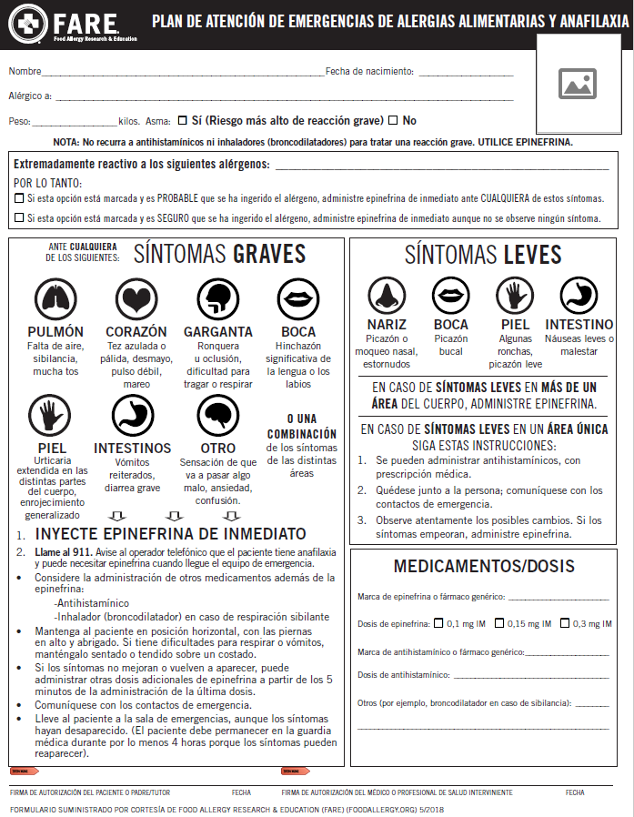
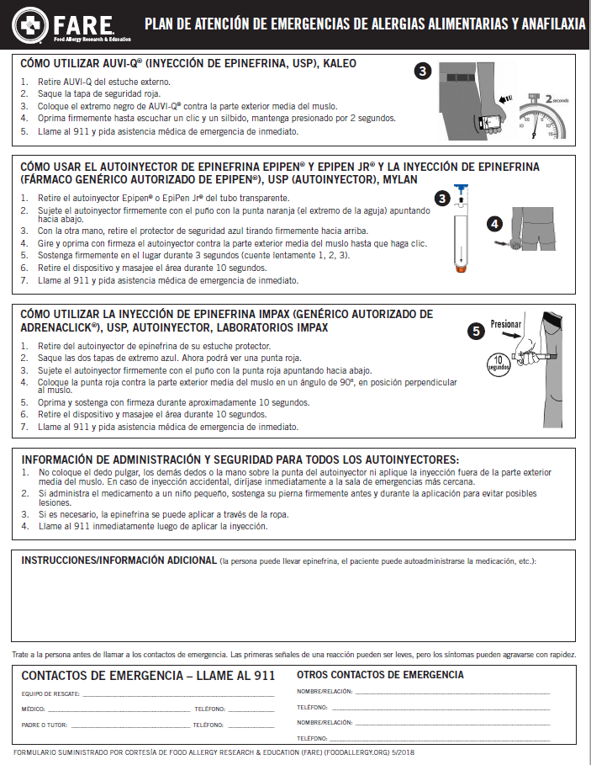

Guidelines for Illness
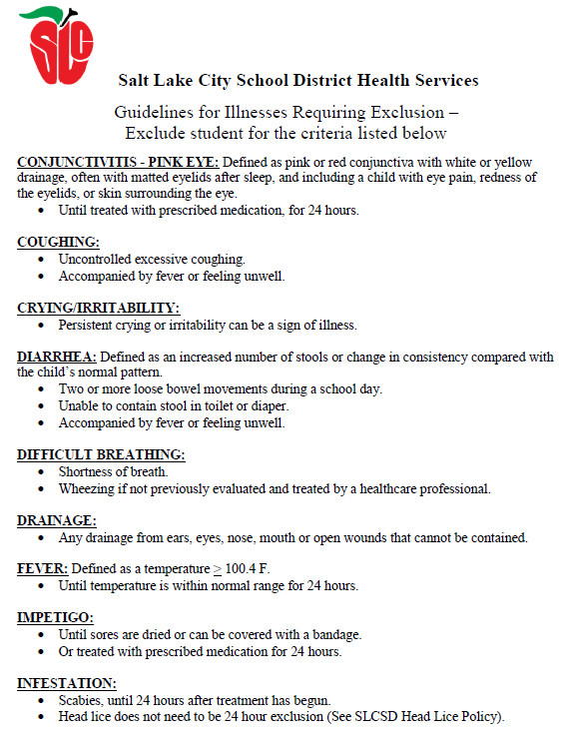

Guidelines for Illness SPANISH
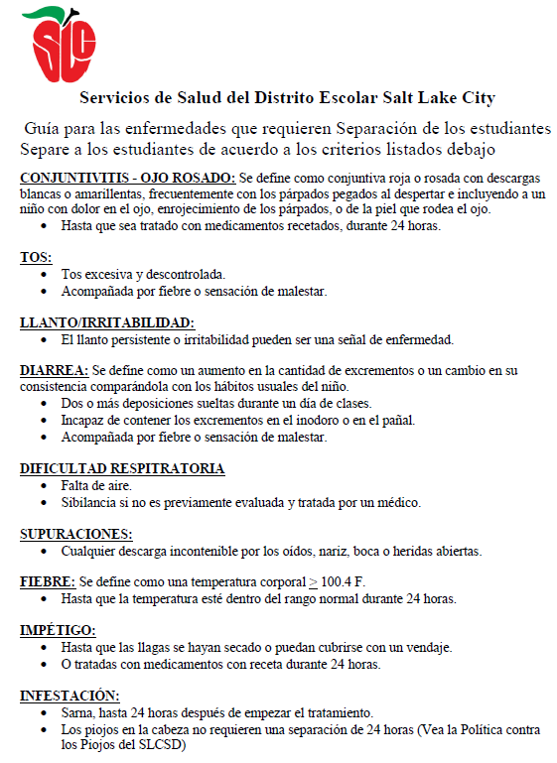
S-9 Medication Form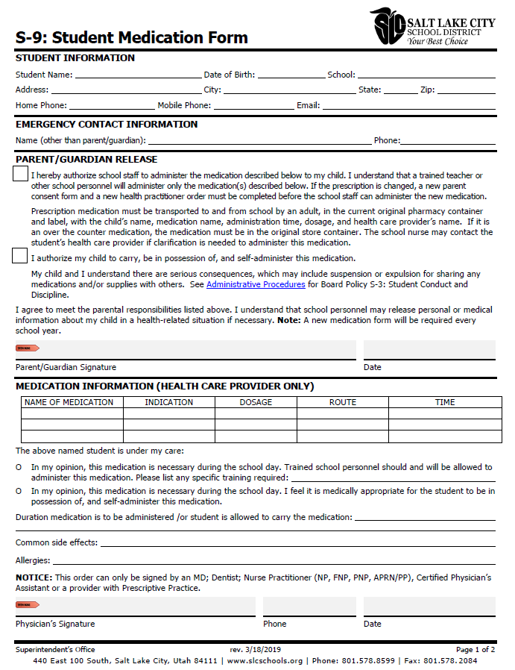
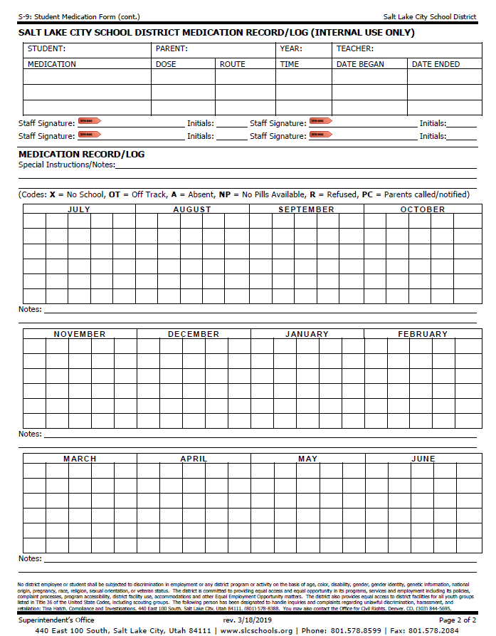

S-9 Medication Form SPANISH
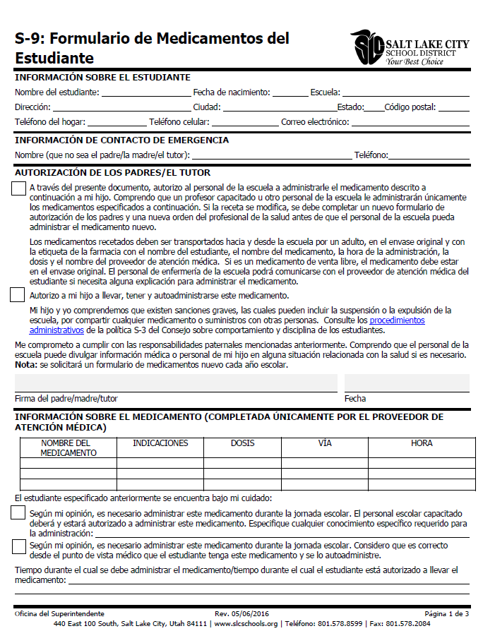
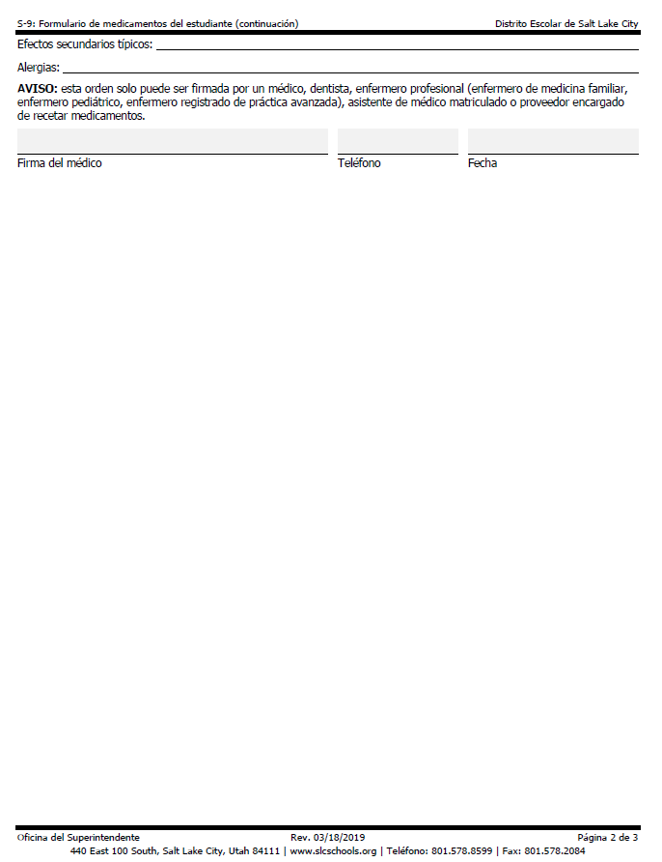

Sunscreen Permission
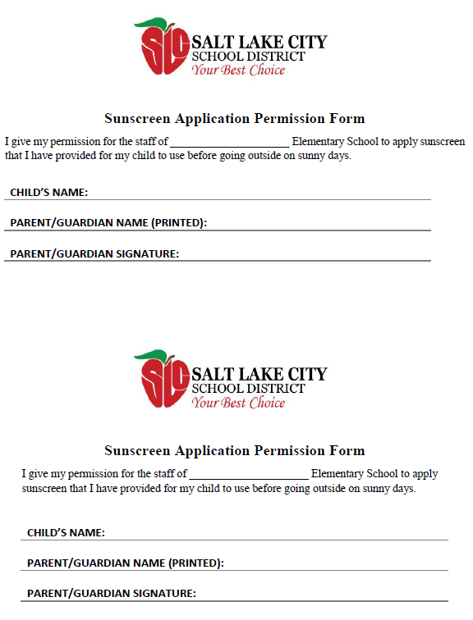

Sunscreen Permission SPANISH
